# 

# Handling Dates in Elasticsearch

## 1. Introduction to Date Handling

In Elasticsearch, dates can be handled in various formats. They can be specified as

1. specially formatted strings,
2. long numbers representing milliseconds since the epoch, or
3. integers representing seconds since the epoch (UNIX timestamps).   
   **NOTE**: The epoch refers to January 1, 1970.
4. Custom Formats are also supported.

While custom date formats can be specified, Elasticsearch provides default behavior for date fields, assuming ISO 8601 format for string timestamps and **UTC timezone** if none is specified.

## 2. Default Date Formats

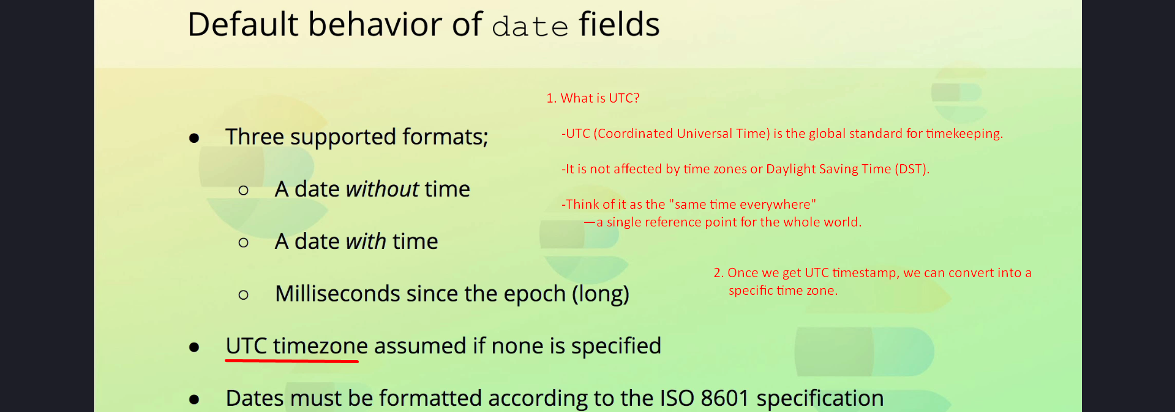

Elasticsearch expects one of the following default formats for date fields:  
1. A date without a time (e.g., '2025-01-18').  
2. A date with a time (e.g., '2025-01-18T15:30:00Z').  
3. A long number representing the number of milliseconds since the epoch.

If a string date is provided, it must follow the ISO 8601 format. For instance:  
- '2025-01-18'  
- '2025-01-18T15:30:00Z'  
- '2025-01-18T15:30:00+01:00'

The 'Z' denotes UTC timezone, while an offset such as '+01:00' indicates the difference from UTC.

## 3. Storage and Conversion of Dates

Internally,

1. Elasticsearch stores dates as long numbers representing the number of milliseconds since the epoch.
2. Even if a string date is provided, Elasticsearch parses it and converts it into a long number.
3. If a timezone is included, Elasticsearch converts the date to UTC before storing it. Queries are then executed against these long values, providing a uniform way of handling dates regardless of their original format.

## 4. Indexing Documents with Dates

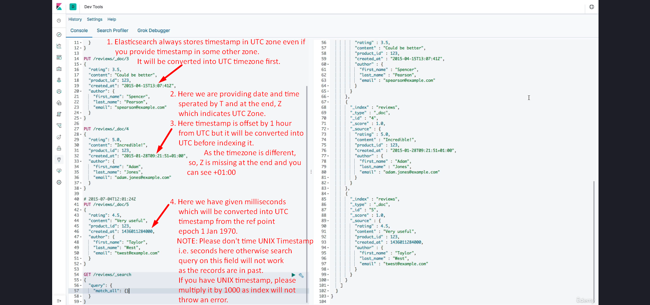

Here are examples of indexing documents with various date formats:  
1. A date without time:  
PUT /reviews/_doc/1  
{  
 "created_at": "2025-01-18" 🡨 Here we have not given time so default is midnight 🡪 00:00:00  
}

2. A date with time in UTC:  
PUT /reviews/_doc/2  
{  
 "created_at": "2025-01-18T15:30:00Z"  
}

3. A date with a UTC offset:  
PUT /reviews/_doc/3  
{  
 "created_at": "2025-01-18T15:30:00+01:00"  
}

4. A long number representing milliseconds since the epoch:  
PUT /reviews/_doc/4  
{  
 "created_at": 1674047400000  
}

Important Note: Do not provide UNIX timestamps (seconds since the epoch) directly. If you have a UNIX timestamp, multiply it by 1,000 to convert it into milliseconds.

## 5. Searching with Dates ( The section by added by ChatGPT only 😊 )

When searching for documents based on date fields, Elasticsearch performs the same conversion as it does during indexing. For example, a query specifying a string date will convert it to a long number before executing the search.

Here is a simple query for searching documents created after a specific date:  
GET /reviews/_search  
{  
 "query": {  
 "range": {  
 "created_at": {  
 "gte": "2025-01-01T00:00:00Z"  
 }  
 }  
 }  
}

## 6. Summary

1. Elasticsearch supports multiple date formats, including ISO 8601 strings, milliseconds since the epoch, and UNIX timestamps.  
2. Dates are always stored as long numbers in UTC, ensuring consistent query behavior.  
3. ISO 8601 is the default format for string dates, with 'Z' indicating UTC and offsets indicating timezone differences.  
4. Always multiply UNIX timestamps by 1,000 to convert them into milliseconds for proper indexing.  
5. Elasticsearch automatically handles date conversion for search queries, simplifying the process for users.